Pre-Calc
Forecast
◄ November 2015 | ~ December 2015 ~ |  |  |  |  | Jan 2016 ►
Sun | Mon | Tue | Wed | Thu | Fri | Sat
 |  | 1 World AIDS Day  Lesson 4.7B  Pgs. 347 43-75 odds, 105  and 111 | 2  Lesson 4.8A  Pg. 357 5-23 odds | 3  Lesson 4.8B  Pg. 357 25-29 odds, 35-41 | 4  Lesson 4.8 Cont.  Worksheet | 5
6 | 7  Test Review  Page 365  85-91 odds; 95-101 odds | 8  Page 365  Test Review  105-117odds; 123-129 odds | 9  Test 4B  Lesson 4.5-4.8 | 10 Human Rights Day | 11  Lesson 5.1A  Page 377  15,21,25-30, 37-45 odds, 59-63 odds | 12
13 | 14  Lesson 5.1B  31-36 all  47-57 odds  75-79 odds | 15  Lesson 5.2A  Hw.  Pg. 385  9-24 all | 16  Lesson 5.2B  Pg. 385  25-42 all | 8  5.1-5.2 Review  Pg. 418  1-27 odds  29-36 all | 9  Review for Quiz  Lesson 5.3A  Hw.  Pgs. 394-395  1-10 all and 11-37 odds | 19
20 | 21  Quiz 5.1-5.2  Lesson 5.3B  Pgs. 394-395  28-42 evens  51-78 Mult. of 3 | 22 Winter Solstice (Northern)  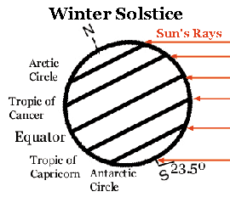  To Be Anounced  Make-Up Day | 23  No School  First Day of Winter  Break | 24 Christmas Eve | 25 Christmas | 26
27 | 28  No School | 29  No School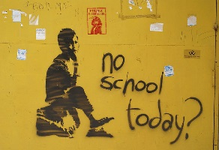 | 30  No school | 31 | Notes:  January 1st First Day Back  January 4th
More Calendars with US Holidays: 2016, 2017, PDF Calendar

