Algebra
Forecast

◄ November 2016 | December 2016 |  |  |  |  | January 2017 ►
Sun | Mon | Tue | Wed | Thu | Fri | Sat
 |  |  |  | 1  Quiz3-4-3-5 and 7-5-7-6 | 2  Handout New Packet  Go over Absolute Values P1-P2 (Use Calc)  Sec. 6-7 pg.327 2-40 Evens | 3
4 | 5  Lesson 3-6 Absolute Value Equations and Inequalities P5-P6  Hw. Pg. 169 4-11, 14-21 | 6  P8-P9 and P6-P7  Show Why? P14  Hw. Pg. 170  23-31-,35,36, 56, 57, 70,71 | 7  Review Prop, solving slope, Elimination, substitution.  Review Packet Worth 10points | 8 Telethon and Review | 9  Unit 3 Test | 10
11 | 12  Handout New packet Start Unit 4A  Sec. 8-1  Zero and Neg. Exponents  Hw. Pg. 397 2-50 Evens | 13  Sec. 8-3  Pg. 407 4-24,  40-45 | 14  Lesson 8-4  Pg, 413 1-22 51, 57-59 | 15  Lesson 8-5  Pg. 420  5-12, 21-23 | 16  Review  Do P11 and hand in | 17
18 | 19  Review  P9 and P10 | 20  Quiz 8-1-8-5 | 21  Winter Solstice (Northern)  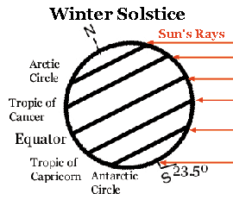  Begin Packet 4B  Do Notes on 8-7 P(a) and P(b) | 22  Hw. Pg. 432 1-30 | 23  No School  First Day of Winter  Break | 24 Christmas Eve
25 Christmas | 27 | 28  No School | 29  No School | 30  No school | 30 | 31
More Calendars with US Holidays: Jan 2017, Feb 2017, PDF Calendar

