ACC. Pre-Calc. Forecast
◄ Dec 2017 | January 2018 |  |  |  |  | Feb 2018 ►
Sun | Mon | Tue | Wed | Thu | Fri | Sat
 | 1 New Year's Day | 2 | 3  Return From Winter Break  Exam Review Handed out. Exam Review Work Day. | 4  10.4 pg. 758 odds  11-15, 19,  E.O.O. 29-49 | 5  Cold Day No School  This Photo by Unknown Author is licensed under CC BY-NC-SA | 6
7  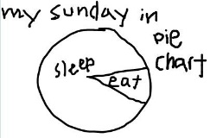 | 8  10.4B pg. 760  Odds 57-71 & Quiz Review pg. 800-801 1-37 odds | 9  Quiz 10.1-10.4 | 10  Lesson 10.7 pg. 781  5-59, 65-75,85,97,  105-109 ALL ODDS | 11  10.8 pg. 789  All 1-12, odds 13-21, E.O.O. 23-47 | 12  Polar Graphs 10.9 Notes and Exploring Project | 13
14 | 15 Martin Luther King | 16  Review  Pg. 800  Evens 2-16, 22-38, 42,44, 66-86, 90-102 | 17  Review  Pg. 801  Odds 1-15, 21-37, 41-43, 67-87, 91-101 | 18  Unit 5 Test | 19  Lesson 9.2 pg. 657 odds 4-49 odds 51-73, odd 83-87, odds 91-93 | 20
21 | 22  Review Day  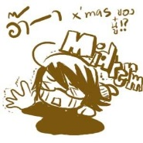 | 23  Exam Review | 24  Mid-Term Exams  1st and 2nd Hour | 25  Mid-Term Exams  3rd and 4th Hour | 26  Mid-Terms  5th and 6th Hour | 27
28 | 29  First Day Second Semester  Textbooks/ Activity/  classroom proceedures | 30  Lesson 9.3 pg. 667 1-4, odds 29-55 | 31  Lesson 9.3 pg. 668  Odds 67-105, 115, 117,133 | 1 2 Groundhog Day

